1. What is the difference between UI and UX? Explain in your own words.

Ans- UI (User Interface):

UI focuses on the visual elements and design of a digital product.

It includes elements such as buttons, icons, colors, typography, and overall layout.

UI designers aim to create an aesthetically pleasing and visually appealing interface that is easy for users to interact with.

The primary goal of UI design is to make the product visually attractive and user-friendly.

UX (User Experience):

UX is a broader concept that encompasses the entire user journey and interaction with a product.

It involves understanding and optimizing the user's overall experience from start to finish.

UX designers consider factors like user research, usability testing, information architecture, and user flows to create a seamless and enjoyable experience.

The primary goal of UX design is to ensure that users can achieve their goals efficiently and with satisfaction while using the product.

1. Who is a frontend developer? Explain the roles and responsibilities in your own words.

Ans- A frontend developer is a type of web developer who specializes in creating the user interface (UI) and user experience (UX) for websites and web applications. Their primary focus is on the client-side of web development, which means they work on the part of a website that users directly interact with in their web browsers. Here are the roles and responsibilities of a frontend developer explained in my own words:

Roles and Responsibilities of a Frontend Developer:

1. UI/UX Design Implementation: Frontend developers take designs and mockups created by UI/UX designers and turn them into functional web interfaces. They translate visual concepts into HTML, CSS, and JavaScript code to ensure the website looks and behaves as intended.

2. Responsive Design: They ensure that websites are responsive, meaning they adapt and look good on various devices and screen sizes, including desktops, tablets, and smartphones. This involves using techniques like media queries and flexible layouts.

3. Cross-Browser Compatibility: Frontend developers make sure that the websites they build work consistently across different web browsers (e.g., Chrome, Firefox, Safari, Edge). They may need to write browser-specific code or use polyfills to address compatibility issues.

4. Performance Optimization: They optimize the frontend code for fast loading times and smooth user experiences. This includes minimizing the use of large images, optimizing code for performance, and utilizing techniques like lazy loading.

5. Interactivity: Frontend developers add interactivity to web interfaces using JavaScript. They create interactive elements, such as forms, navigation menus, and animations, to enhance the user experience.

6. Accessibility: Ensuring that websites are accessible to all users, including those with disabilities, is a critical responsibility. Frontend developers use semantic HTML, ARIA roles, and other techniques to make web content usable by screen readers and assistive technologies.

7. Version Control: They often use version control systems like Git to collaborate with other developers and track changes to the codebase. This helps manage code efficiently and enables teamwork.

8. Testing and Debugging: Frontend developers test their code across various devices and browsers to identify and fix issues. They use debugging tools and techniques to troubleshoot and ensure the website works correctly.

9. Continuous Learning: Keeping up with the ever-evolving web technologies and best practices is essential for frontend developers. They need to adapt to new tools, frameworks, and coding standards to stay relevant in their field.

10. Collaboration: Frontend developers work closely with backend developers, UI/UX designers, and other team members to ensure that the entire web application functions seamlessly. Effective communication and teamwork are crucial.

Who is a backend developer? Explain the roles and responsibilities in your own words.

Ans- A backend developer is a type of software developer who specializes in building and maintaining the server-side of web applications and software systems. They work behind the scenes, focusing on the server, databases, and application logic that enable the frontend (user interface) to function effectively. Here are the roles and responsibilities of a backend developer explained in my own words:

Roles and Responsibilities of a Backend Developer:

1. Server-Side Development: Backend developers are responsible for creating the server-side infrastructure that powers web applications. They use server-side programming languages like Python, Ruby, Java, PHP, or Node.js to handle requests and serve dynamic content to users.

2. Database Management: Backend developers design, implement, and maintain databases to store and manage data efficiently. They work with database management systems (DBMS) such as MySQL, PostgreSQL, MongoDB, or SQL Server to ensure data integrity and reliability.

3. API Development: They create application programming interfaces (APIs) that allow different parts of a system or external applications to communicate with the backend. APIs are crucial for data exchange and integration with third-party services.

4. Security: Ensuring the security of data and system functionality is a top priority for backend developers. They implement security measures like authentication, authorization, encryption, and input validation to protect against vulnerabilities and data breaches.

5. Scaling and Performance: Backend developers optimize the performance of web applications to handle increased user traffic and data loads. They may use caching mechanisms, load balancing, and database indexing to improve system responsiveness.

6. Server Management: Backend developers often deploy and manage web servers, ensuring they are properly configured and maintained to handle the application's requirements. They may work with serverless technologies or cloud platforms like AWS, Azure, or Google Cloud.

7. Code Maintenance and Refactoring: Ongoing maintenance and refactoring of code are essential tasks. Backend developers update code to fix bugs, improve efficiency, and adapt to changing requirements or technology updates.

8. Collaboration: They collaborate closely with frontend developers, database administrators, and other team members to ensure seamless integration between the frontend and backend components of a web application. Effective communication and teamwork are crucial.

9. Version Control: Backend developers use version control systems like Git to track changes, collaborate with teammates, and manage codebase history.

10. Monitoring and Troubleshooting: They monitor server performance, diagnose issues, and implement solutions to maintain system uptime and reliability. Monitoring tools and error tracking are commonly used for this purpose.

11.Documentation: Backend developers document their code, APIs, and system architecture to facilitate communication within the team and help with future maintenance and enhancements.

4.Create your own GitHub & LinTedIn accounts. Yhare the screenshot of both of your accounts and share your profile links of GitHub & Linkedin in the solution.

Solution-

<https://github.com/Nabhgupta08>

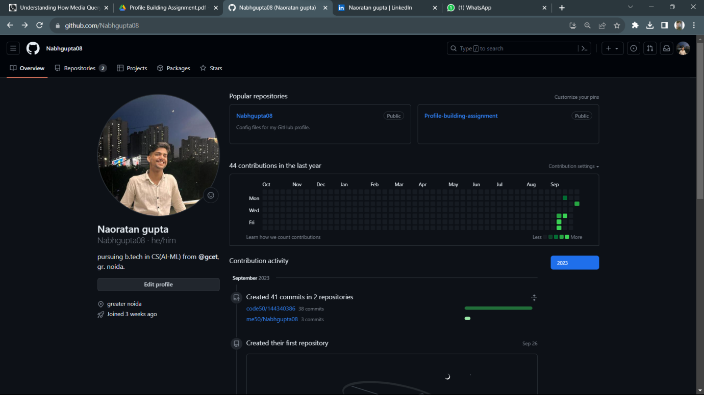

<https://www.linkedin.com/in/naoratan-gupta-595352293/>

